37-12 Prince Street
Flushing, NY 1135
Phone (718) 939-5100
Fax (718) 939-9235

LIBRARY

The Elements of Citation

The primary elements of a bibliographic reference are the same for most styles of documentation, although the order in which they are presented may vary. These elements include the name of the author, the title, the place of publication, the publisher's name, the date of publication, and a designation of the location, or page number, of a reference. Many styles also include a designation of the publication medium. For electronic sources, however, some elements may be missing or must be translated into elements that make sense in a new era of publishing. For example, in place of an author's name, online authors may only use login names or aliases. Instead of a title, there may only be a file name. The place of publication and the name of the publisher are replaced online by the protocol and address, and, rather than a date of publication, the date you access the site may be the only means of designating the specific "edition" of an online work. On the WWW, a given site is always one page, regardless of its length. Pagination is thus an element of print publication that has little or no meaning in electronic documents or files. Since most Web browsers, word processing packages, and text editors allow the reader to search for specific words or phrases within a document, designating the location of a specific reference within an electronic document or file may be redundant.

Choose a Citation style from the lists below.

Book, one author
Book, two or three
authors or editors
Book, four or more editors | 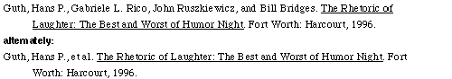

Book, written by a group

Book with no author
Work of more than one volume | 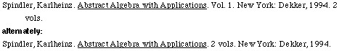

Book in a foreign language
Book, a second, third, or later edition

Book, a chapter in

Article in a scholarly journal

Article in a popular magazine
Article in a weekly or
bi-weekly magazine
Article in a monthly
magazine-author named
Article in a newspaper | 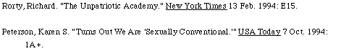
Reference work or encyclopedia  (familiar or online) | 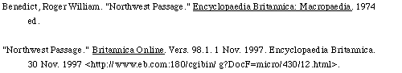
Reference work (specialized
or less familiar)

Bulletin or pamphlet
Government document | 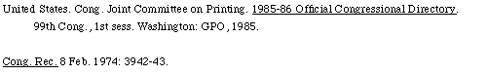

Computer software
WWW page, generic | 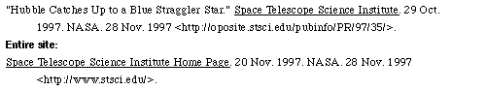
WWW page, online book | 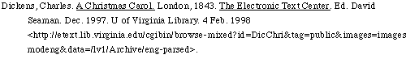
WWW page, online  scholarly journal | 
WWW page, online
popular magazine
WWW page, personal home page
Listserv/Newsgroup/  Usenet newsgroup | 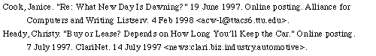
Email
CD-ROM/diskette database  or publication | 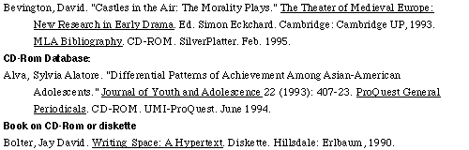
Microfilm or microfiche
Movie
Radio program
Personal interview
Musical composition | 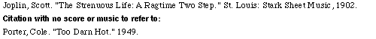

Recording

Notes
- Arrange the items on your reference list alphabetically by author, interfiling books, articles, etc.
- Doublespace all lines.
- Indent the second and following lines 5 spaces (or one half inch).
- If no author is given, start with the title.
- Abbreviate the names of all months except May, June, and July.
- If the encyclopedia does not arrange its articles alphabetically, treat the encyclopedia article as if it were a book article. Specific volume and page numbers are cited in the text, not in the list of references.
- Gale Reference Book: cite the original source being reprinted as shown under Book, Journal Article, Newspaper or Magazine Article, etc. The example shows a Magazine Article. Then include the citation information for the reference book.
- Websites: include the title of the web page, the name of the entire web site, the organization that posted it (this may be the same as the name of the website). Also include the full date the page was created or last updated (day, month, year if available) and the date you looked at it.
- Internet Magazine Articles: Include the name of the database (underlined) and the company that created it and its home webpage; the full date of the article (day, month, year if available) and the date you looked at it; as well as the library or other organization (and its location) that provided you with access to the database. If you are citing a journal instead of a magazine, include the volume (and issue number) and date as shown under the Journal Style above.
- The rules concerning a title within a title are not displayed here for purposes of clarity. See the printed version of the manual for details.
The Modern Language Association of America. MLA handbook for writers of research papers. New York: MLA, 1999. 5th. edi. pp.111 - 210

Documenting Sources in the Text

Parenthetical or in-text references to print publications usually include the author's last name and the page number of the reference (humanities styles) or the author's last name, the date of publication, and the page number of the reference (scientific styles). Often, for electronic sources, some or all of these elements may be missing. Thus, parenthetical references to electronic sources will usually include only an author's last name or, if no author's name is available, the file name, and, for scientific styles, the date of publication or the date of access if no publication date is available.

For files with no designation of author or other responsible person or organization, include the file name in parentheses (i.e., cgos.html). For scientific styles with no designation of publication date or date of last revision or modification, include the date of access instead, in day-month-year format (i.e., 16 Aug. 1996).

List navigational aids such as page, section, or paragraph numbers, if they are included in the original text, at the conclusion of the citation, separated by commas. For most electronic sources, however, navigational aids will not be included.

In citations of print sources, subsequent references to the same work need not repeat the author's name, instead giving the different page number or location, if applicable. With electronic documents that are not paginated or otherwise delineated, however, repeating the author's name may be the only way to acknowledge when information is drawn from a given source.

